The Most Important Metal (Project 2) - Giacomo Bizzotto
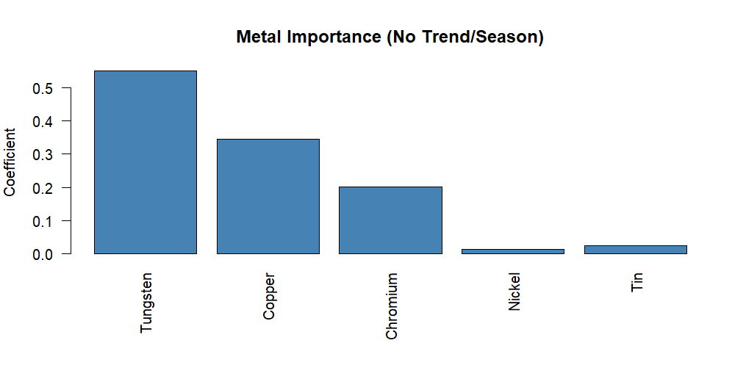
Figure 1: Metal Importance (No Trend/Season) - TSLM Model
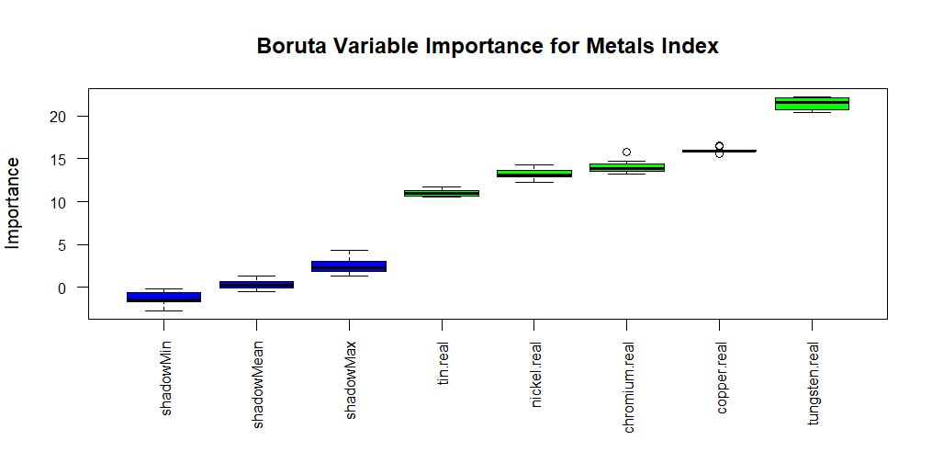
Figure 2: Boruta Variable Importance for Metals Index

Discussion of Results:
Both the TSLM and Boruta models identify tungsten as the most influential metal in explaining movements in the Metals Index between 1959 and 2010. In the TSLM, tungsten shows the largest positive coefficient, indicating that changes in its real price have the strongest effect on the overall index. The Boruta Random Forest confirms this result, ranking tungsten far above the other metals in importance. Copper and chromium show moderate influence, while nickel and tin contribute minimally. The agreement between linear and nonlinear models reinforces the robustness of tungsten’s dominant role in the Metals Index.

